**VO2 Max Formulas**

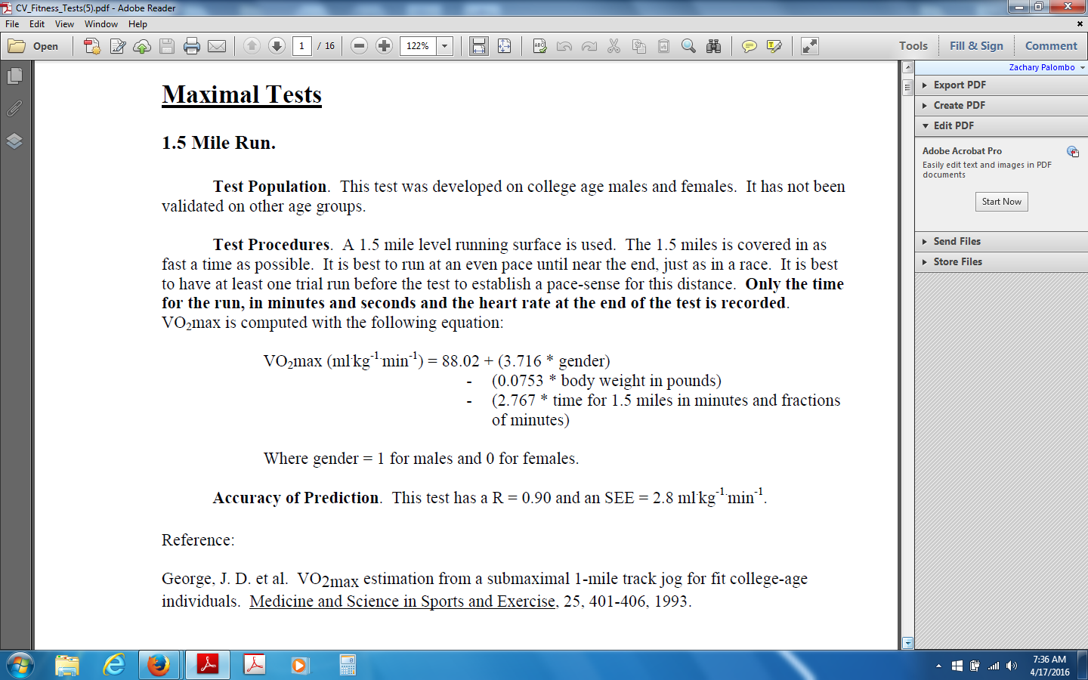

**Cooper Fitness Test**

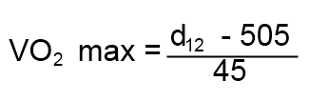

**d = Distance covered in 12 minutes**

**runningforfitness.com**

**5K VO2 Max Test**

VO2max=125-3.6*T

T is your 5K race time in minutes.

School of Human Sciences

St Mary's University College, [UK]

**Cycle Watts VO2 max**

Relative VO2Max = [(10.8 x W)/M] + 7

Where:  W = watts M = cyclist weight in kg

Peakscoachinggroup.com / USA Cycling & Triathlon

Concept2

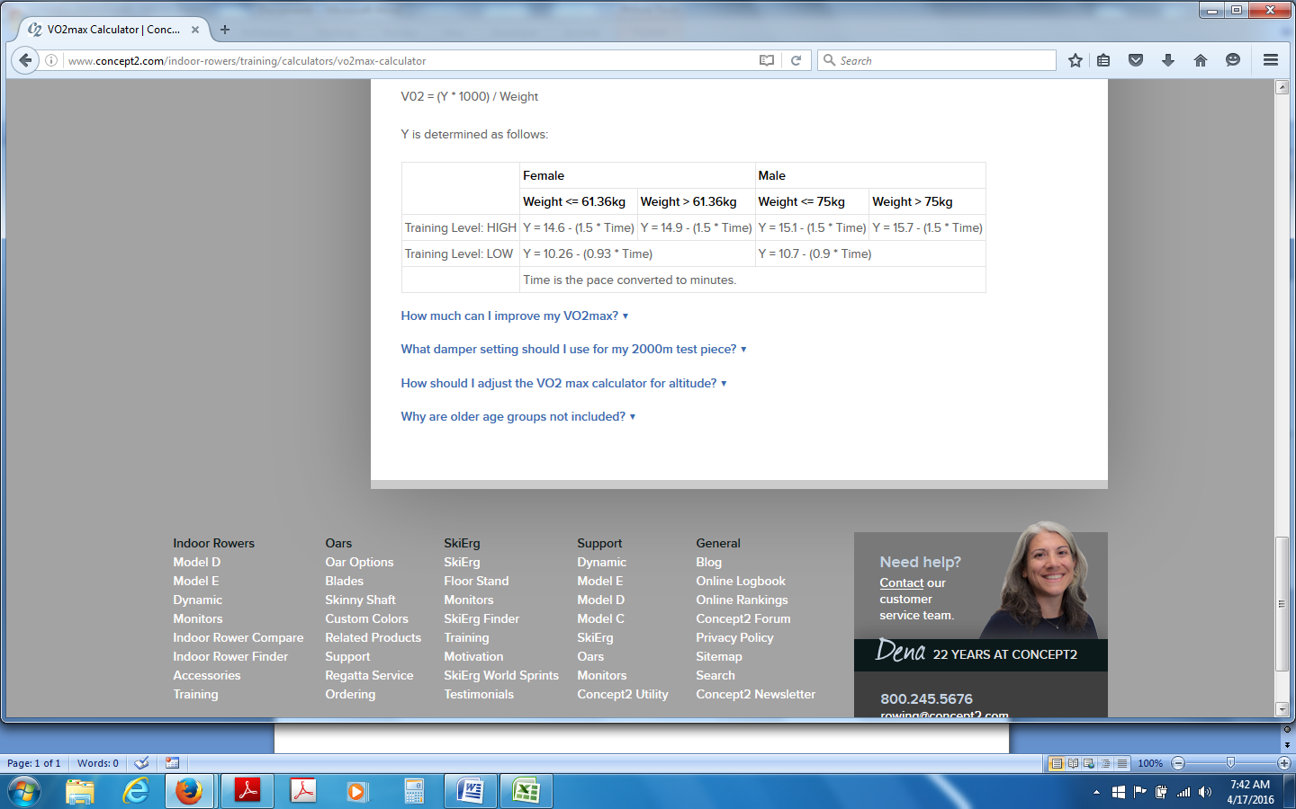

**Resting Heart Rate**

VO2max = 15.3 x (MHR/RHR)

Where:  
MHR = Maximum heart rate (beats/minute) = 208 - (0.7 x Age)  
RHR = Resting heart rate (beats/minute) = 20 second heart rate x 3

